Students (Student_Id, Student_Name, Studaddress ,Student_Batch, deptartment ,CGPA)

Instructors (InstructorId, InstructorName, salary, joingdate) Courses (CourseId, CourseName, CourseCreditHours, InstructorId) Registration (StudentId, CourseId, Grade)
Tasks:

- Create all the above tables in the database.

- Identify all primary and foreign keys in the tables and add primary keys and foreign keys using Alter command.
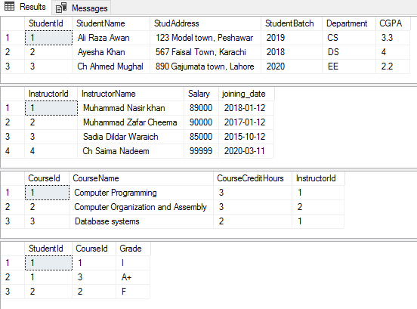
- Insert the following values for tables of student, instructors, Courses, and registration respectively.

- Apply all sql constraints that we have cover so far in lab manual.

